Task 1: Automated network policy engine
Scenario: continuously check the controller and block high-bandwidth consumers during peak hours.
Implementation: task1/policy_engine.py uses requests against the ONOS northbound REST API. It reads devices (GET), parses port statistics from the JSON response and POSTs an ICMP drop rule between 10.0.0.1 and 10.0.0.2 when a port exceeds the threshold.

Output
Command: sudo MN_USERSPACE=1 python3 task1/task1_topo.py (ONOS fwd app active)
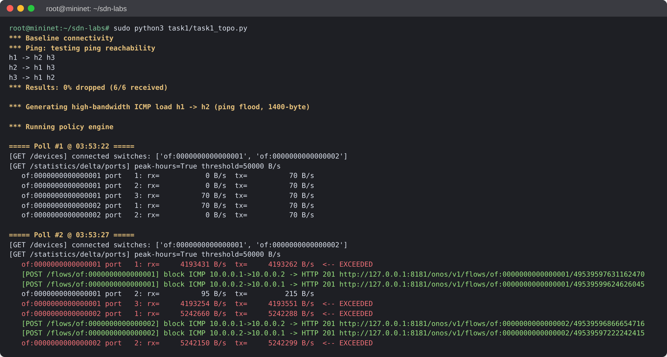
Figure 1.1: Device discovery, port statistics, and threshold breach with POST /flows (HTTP 201)
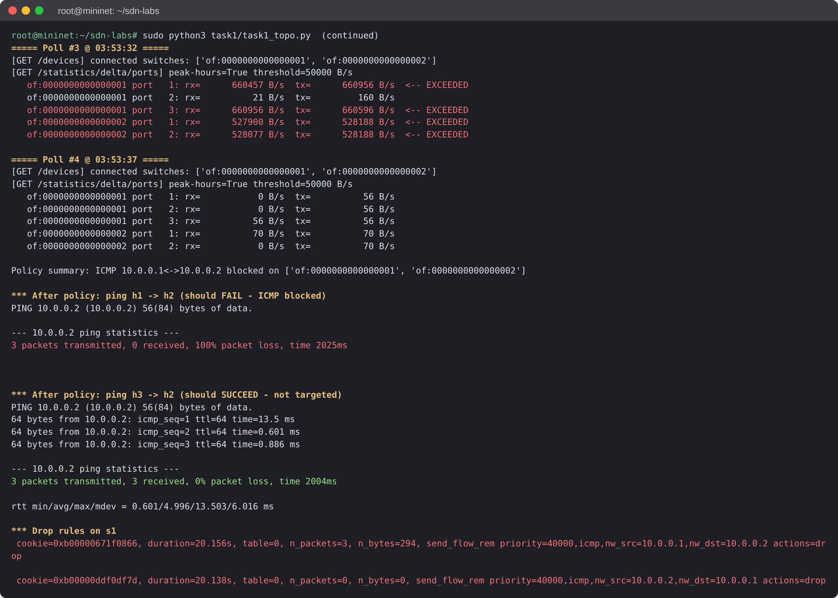
Figure 1.2: Policy result: h1→h2 ICMP blocked, h3→h2 unaffected, drop rules on s1

Task 2: Broadcast-storm prevention with MAC learning
Scenario: prevent broadcast storms caused by topology loops.
Implementation: task2/loop_safe_switch.py is an os-ken (Ryu API) application, tested on a three-switch triangle topology that forms a physical loop.

Output
Commands: python3 run_osken.py task2/loop_safe_switch.py 6633 and sudo MN_USERSPACE=1 python3 task2/loop_topo.py
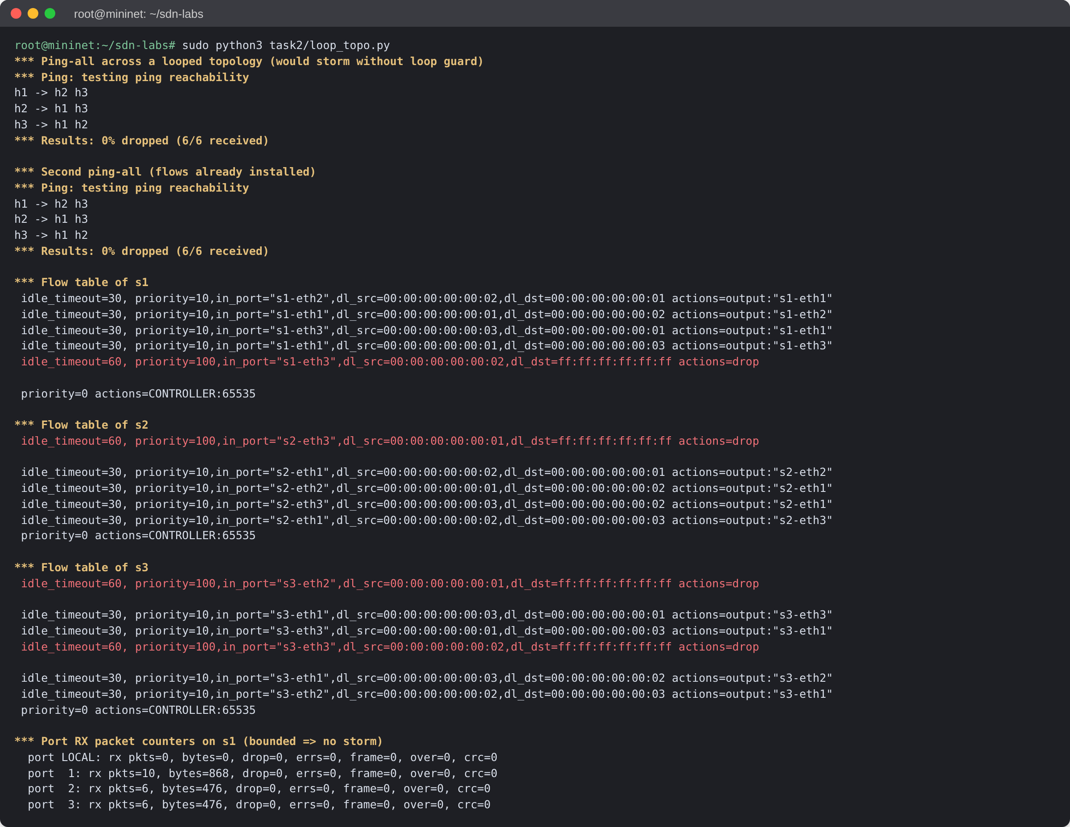
Figure 2.1: Mininet: ping-all over the looped topology and resulting flow tables (learned and DROP rules)
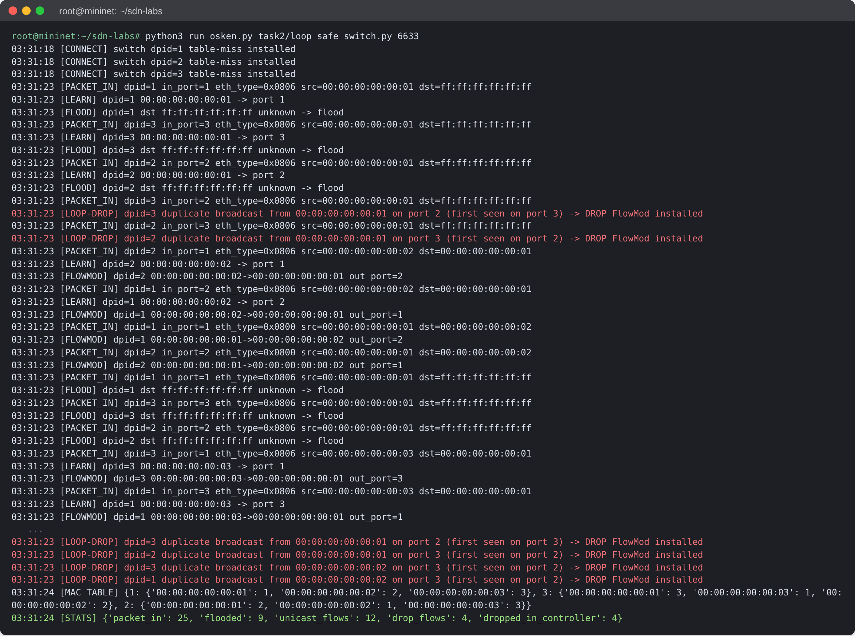
Figure 2.2: Controller log: PacketIn parsing, MAC learning, flooding, FlowMods, and loop-drop decisions

Task 3: 5G campus network slicing with QoS queues
Scenario: two isolated slices share one OpenFlow switch. Slice A carries streaming video and Slice B carries control signalling.
Implementation: task3/slice_qos.sh holds the ovs-vsctl and ovs-ofctl commands. task3/slice_topo.py runs the Mininet test and generates traffic with iperf3.

Output
Command: sudo MN_USERSPACE=1 python3 task3/slice_topo.py
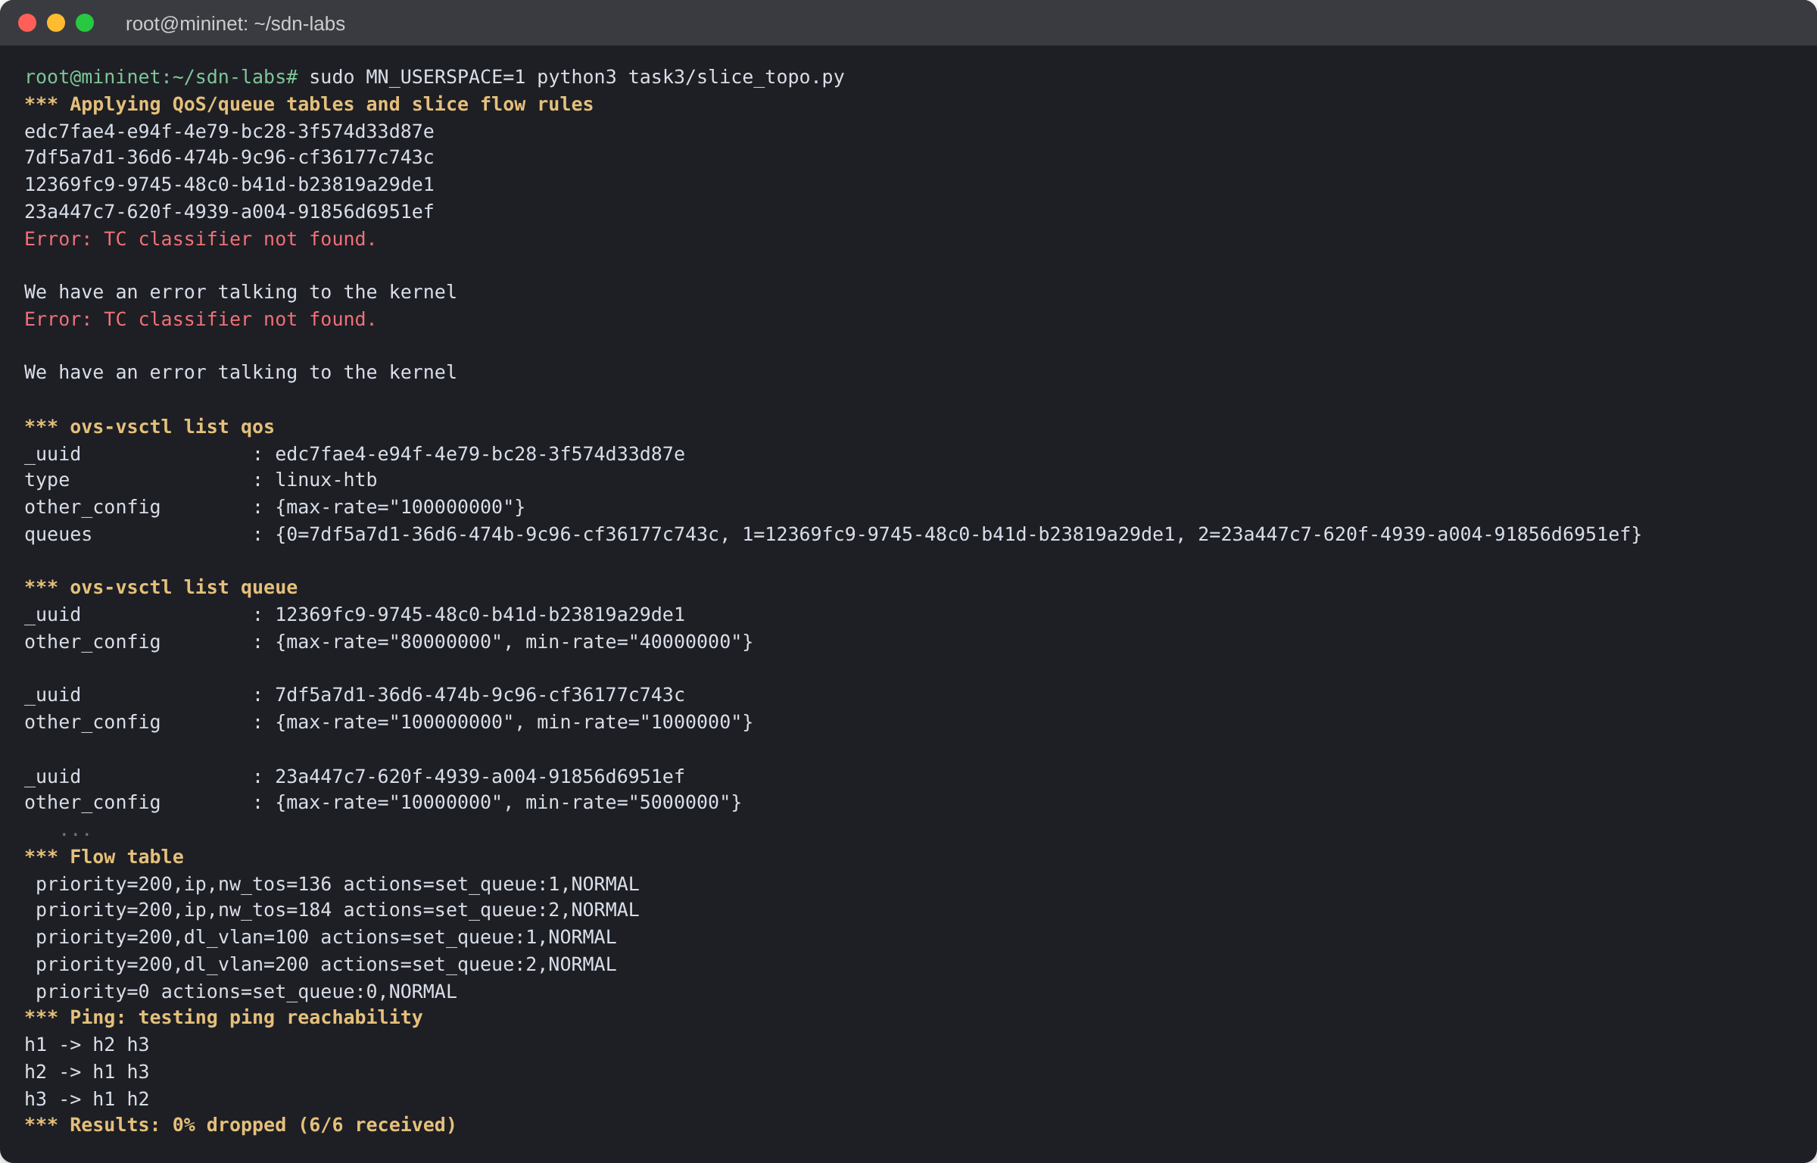
Figure 3.1: QoS and Queue tables created on egress port s1-eth3, plus the slice flow rules
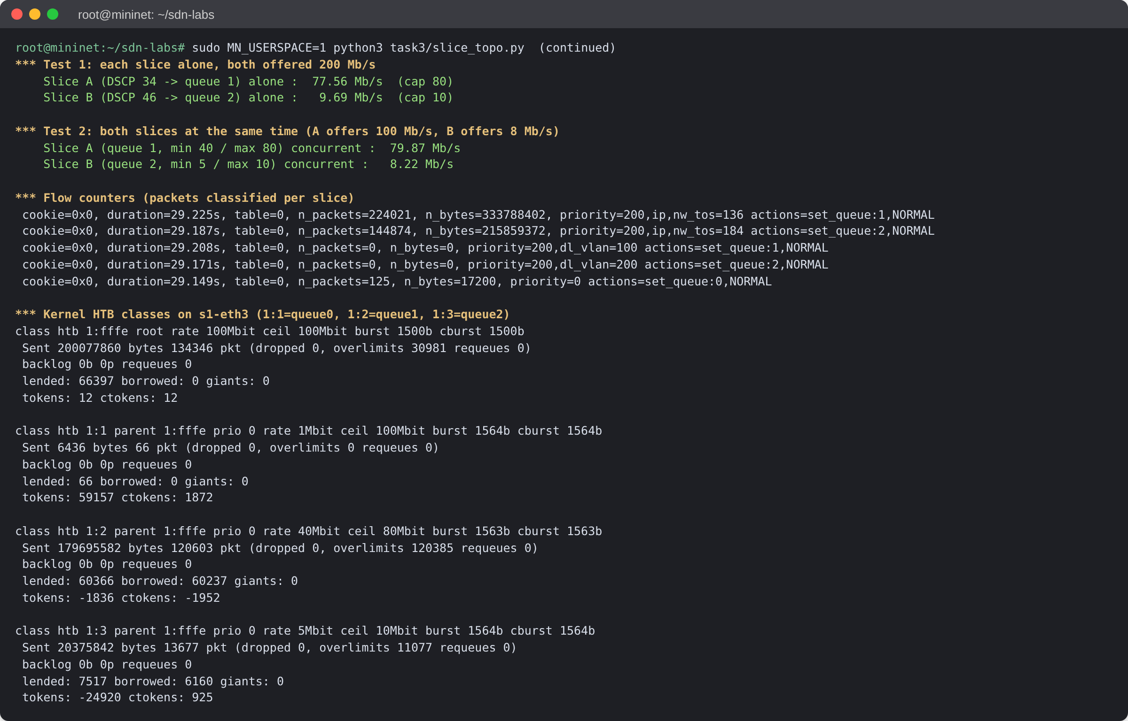
Figure 3.2: Measured slice rates, per-slice flow counters, and kernel HTB queue counters

Task 4: ONOS Intent Framework with automatic rerouting
Scenario: use high-level intents instead of manual flow rules, so traffic reroutes automatically when a link fails.
Implementation: task4/intent_manager.py calls the ONOS REST API. task4/task4_topo.py builds a diamond topology (s1–s2–s4 and s1–s3–s4) and fails the active link.

Output
Command: sudo MN_USERSPACE=1 python3 task4/task4_topo.py (ONOS fwd app deactivated)
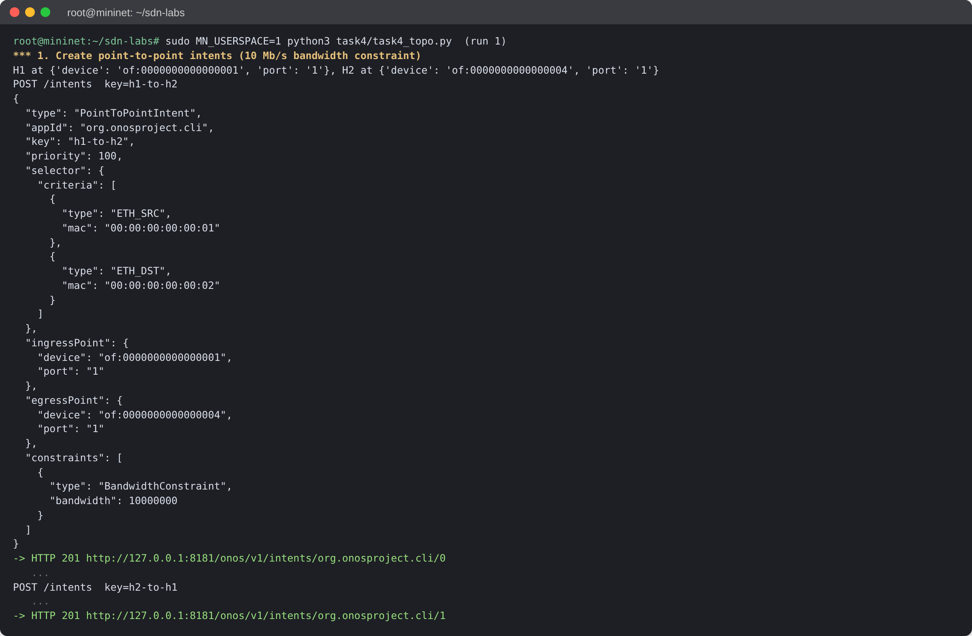
Figure 4.1: Run 1: PointToPointIntent payloads with BandwidthConstraint, created with HTTP 201
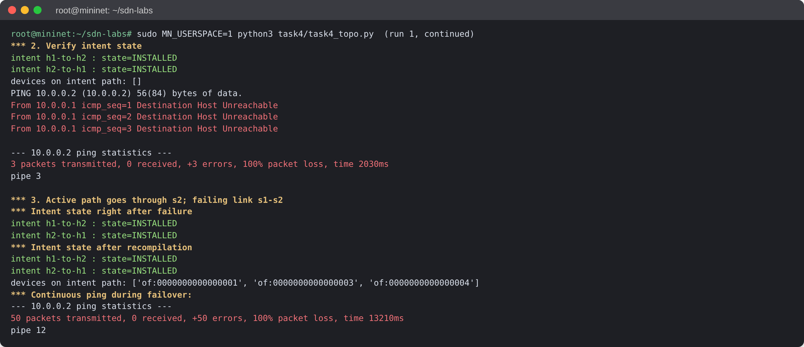
Figure 4.2: Run 1: intents INSTALLED, link s1–s2 failed, ONOS recompiled the path onto s1–s3–s4
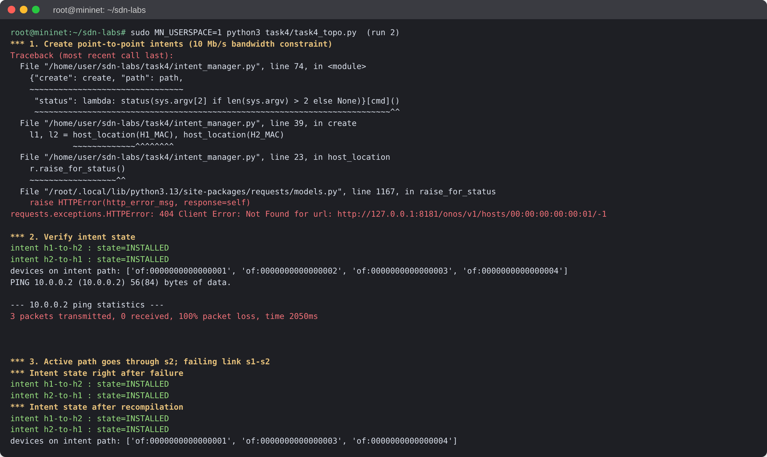
Figure 4.3: Run 2: intent creation failed (hosts not discovered, HTTP 404); states shown are the run 1 intents

